LAB 8

EXERCISE 2

QUESTION 5

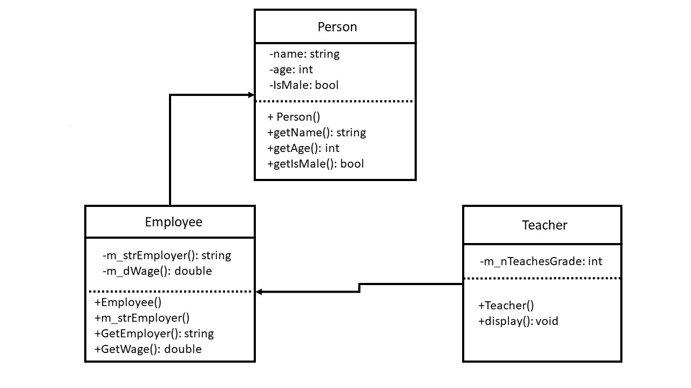

The object of Teacher is created with the arguments. Those arguments are pass into the constructor of the Teacher. The initializer list of the constructor of Teacher is then pass those arguments into the class’s constructors. It call the function of display and print out those statements.